1. We first, went to this link

<https://authjs.dev/getting-started/adapters/prisma>

1. Then we copy pasted the User model and then modified it as we are not using providers like google and GitHub in here

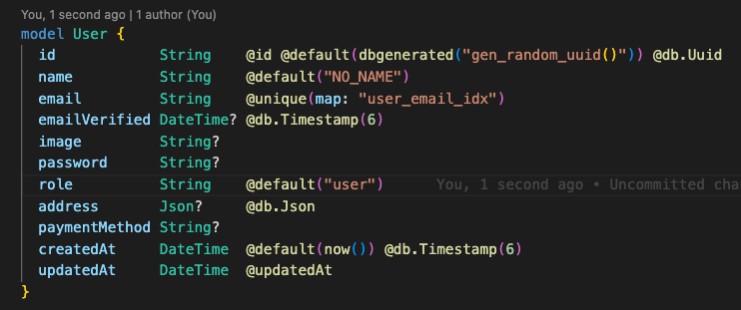

1. Now we added the Account Model

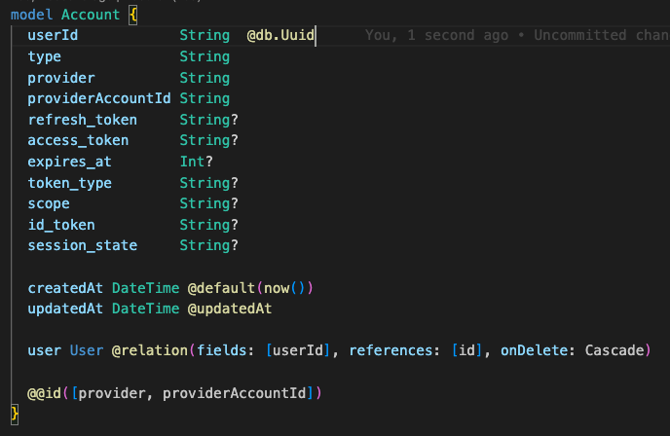

* But we need to add this to our previous User model as well

1. We added the session model as well

* Then updated our user model

1. And finally, the verification token model

1. Now we need to make new client and migrations

* First, we generate new client

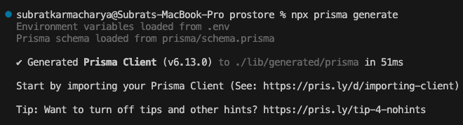

* Then we run migrations. (NOTE: THIS TOOK 2 3 TRIES)

* Then we run Prisma studio and check out the new tables

